WordQ

Setting up a user name and saving
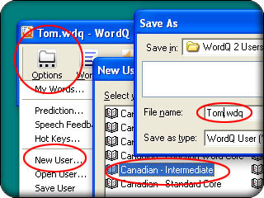

Open WordQ, then:
- Find and click on the Options button (far left of WordQ's tool bar).
- Click on menu item "New User."
- Choose a vocabulary and then click on Next.
- Type in a name (overtyping *.wdq")
- Click Save to save this user file.

Choosing font sizes and styles
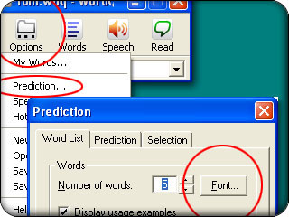
To change the font:
- Go to Options,
- Find and click on Predictions...
- Click on the Font button

Choosing a voice
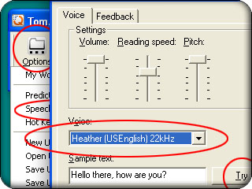
- Go to Options,
- Click on Speech Feedback...
- You can hear an example sentence read by pressing the Try button. Note that WordQ will show all voices installed on the computer, but not all may work work properly with WordQ. In particular, do not use any IBM ViaVoice voices.
The default Acapela "Heather" voice or "Microsoft Mary" are recommended as being the clearest.

Moving the Prediction Box
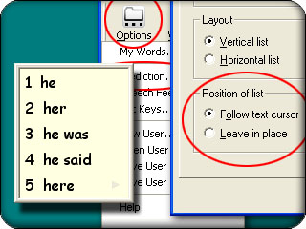
The default setting in WordQ is for the prediction box to follow the cursor. However, if you are using quite a lot of text, especially web pages, you may find that this gets in the way with the box covering the text you want to read. Some people also prefer to have the box always in a fixed place so that they can look for suggestions in a constant location.

To keep the prediction box in a single location:
- Go to Options
- Click on Predictions...
- Click on Leave in place
You can move the prediction box by clicking on its title bar and dragging it. The bottom right-hand corner of the screen is a common preference.
Hiding/showing the word prediction box:
Click on the Words button in the WordQ toolbar and/or by pressing the F9 function key. This is a fast way to get the prediction box out of the way especially when viewing Web pages. Also, when writing, they can hide the prediction box until they need help.

SpeakQ
Training your speech
Click on Options (Open User if it’s not already opened)
Select “Speech Recognition”
Under Recognition Profiles (the 2nd box), select your user from the drop down menu, or click on “New”
Click Ok
Click on Options
Select “Train Speech”
Choose a training text, and select open.
Click on “Train”.
.
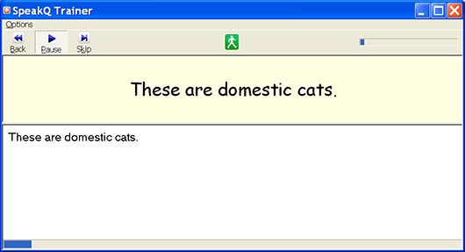
The training window presents chunks of a sentence for reading. The text is read aloud and highlighted. The user then speaks the text. Recognized text is displayed under the original text.
At any time the user can go back, pause or stop. The passage can be re-read. If words are not recognized, then the unrecognized words are displayed and spoken and the individual has the chance of speaking them again.
It is recommended that you train at least 3 different texts. In 15 minutes, a sample of 800-1000 words are saved. A progress bar at the bottom of the screen tells you how far in the training you have gone.

More training
When you start off using the speech recognition feature, you may find that the recognition of words is not quite as accurate as when you carried out the training. With practice, the recognition will improve. You can do additional training to improve recognition with text similar to that which you are going to write about.
Train words
This feature in the Options menu lets you add new words with unusual spelling, or pronunciation.

Starting to speak
The microphone automatically turns off whenever you:
- click with the mouse
- use the arrow keys
- press escape
- select the microphone icon from the toolbar.
F8 also toggles the microphone off or on.
You can make corrections in your document without worrying about unwanted recognitions being inserted.

Speech feedback as you speak
SpeakQ can speak back any words it has recognized. This feature can be turned off.

Speech recognition modes
There are two modes for speech input in SpeakQ.
- Speak and select
Spoken words and phrases are displayed as a list of choices in the word prediction box. The program enters what you say in the box after you make a pause. You then select from the list of words or phrases using the keyboard or mouse. You can speak individual words or phrases. SpeakQ will speak the first option in the list. Hovering the mouse over other choices in the prediction box enables each choice to be spoken aloud.
If you speak a single word, then you may see several similar sounding words displayed.
You cannot select the words from the prediction box by saying the corresponding number. You need to select with a mouse or keyboard. In this mode, you must type punctuation marks rather than speak them. The word by word pace is slightly slower when dictating through the word prediction box.
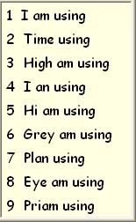
Only words contained in your word prediction user vocabulary are suggested in speak and select mode.
- Speak continuously
Words are typed into the document as you say them. Words outside the WordQ vocabulary may be recognized in this mode.

Computer navigation
There are a limited set of punctuation commands:
- Period
- Question mark
- Comma
- Colon
- Semi-colon
- Exclamation point
Making corrections
Recognized text placed in the document can be spoken aloud with highlighting, giving the writer feedback and assistance with editing. Using WordQ / SpeakQ, the writer can use the keyboard to type over any errors. They can press Escape quickly to undo the recognized phrase and redo it, either by typing from the keyboard or using the word prediction.

