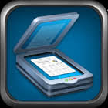
Tiny Scan Pro--PDF
Use: Scanning documents into ipad

- Open Tiny Scan Pro app.
- Select camera icon in upper right corner.
- Take picture of the paper you want to import.
- Move the corners so they will crop the image to the correct dimensions (remove excess around page)
- Click Next
- Choose color, grayscale, or Black & White (on bottom, under photo). You can also adjust the brightness and contrast with the sun button. Select Save.
- To Open in another app, select the box with arrow, and choose Open in. Select the desired app.

