
Making Sequences
Use: Sequencing Assignments

To create a new sequence:
- Using iPad camera, take a picture of the paper that needs to be sequenced (as many times as there are sequencing items….if there are 4 items to sequence, take a picture 4 times). **
- Go to Camera Roll (bottom left corner) and select that picture.
- Touch anywhere on the screen to get a toolbar on top.
- Click Edit (top toolbar)
- Select Crop (bottom toolbar).
- Move corners so only one of the photos is showing.
- Select Crop (upper right corner)
- Select Save
- Continue to do so for the remaining images until you only have the individual pictures.
** Alternatively, you can cut the pictures apart, and then take individual photos of them.**
- Open Making Sequences App.
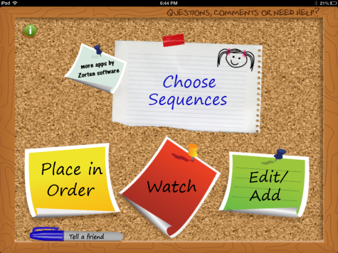
- Select Edit/Add
- Select Add a new sequence
- Select Add an image and audio
- Click Choose from Library.
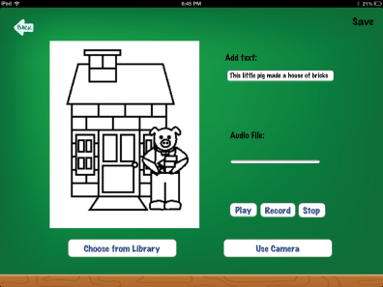
- Select the picture you want.
- Type text in the “Add Text” box at the top
- You may choose to record a sentence as well (e.g., The piggy made his house out of sticks.)
- Save (top right corner)
- Continue selecting “Add an image and audio” until you have all of the pictures in the sequence.
- Type in a sequence name in the top white text box (e.g., The 3 Little Pigs)
- Select Save
- Be sure your images are in the correct order. If they aren’t, select “Re-Order/Delete” (top right corner). Grab the white lines to move the image to a new location.
- Save.
To DO the sequence activity:
- Open Making Sequences app.
- Select Choose Sequences
- Select the sequence activity you wish to complete (a green check mark will be placed next to the selected sequence).
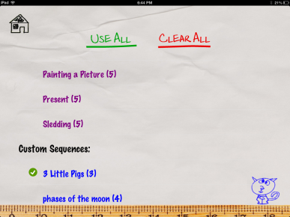
- Press the home button (upper left corner)
- Select Place in Order

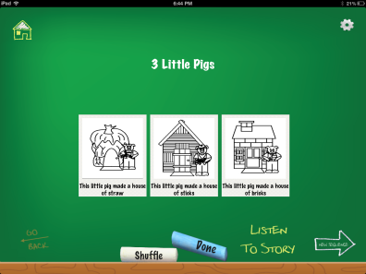

- Drag and drop to put items in order.
- Select Done to see if you are correct.
- To save the sequence, take a screen shot by holding down the power and nuvi button. The image will be in your camera roll. It can be emailed from there.

